BOX MODEL

1. BOX MODEL

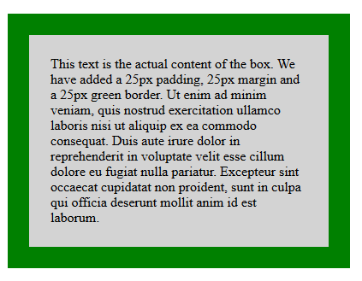

Keterangan:

Content : konten yaitu isi element dimana teks dan gambar muncul

Padding :jarak antara isi/content dengan border

Border :garis tepi/ batas dari elemen

Margin :jarak tepi luar elemen dengan elemen lain

Width :lebar Kontent

Height : tinggi kontent

SOURCE CODE

<html>

<head>

<style>

div {

background-color: lightgrey;

width: 300px;

border: 25px solid green;

padding: 25px;

margin: 25px;

}

</style>

</head>

<body>

<h2>Demonstrating the Box Model</h2>

<p>The CSS box model is essentially a box that wraps around every HTML element. It consists of: borders, padding, margins, and the actual content.</p>

<div>This text is the actual content of the box. We have added a 25px padding, 25px margin and a 25px green border. Ut enim ad minim veniam, quis nostrud exercitation ullamco laboris nisi ut aliquip ex ea commodo consequat. Duis aute irure dolor in reprehenderit in voluptate velit esse cillum dolore eu fugiat nulla pariatur. Excepteur sint occaecat cupidatat non proident, sunt in culpa qui officia deserunt mollit anim id est laborum.</div>

</body>

</html>